**Covid 19 Management System Project Overview**

# MENU

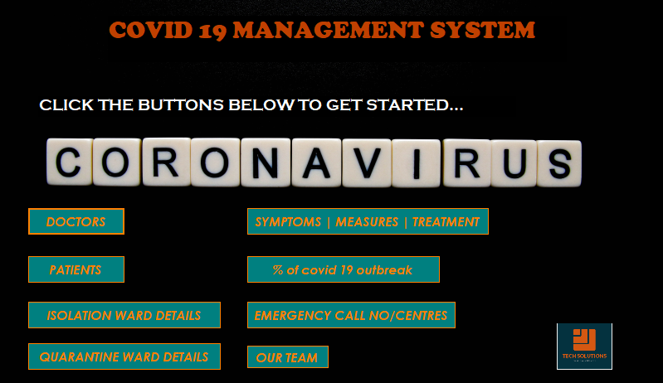

* CLICKING DOCTORS FROM MENU

# CLICKING VIEW

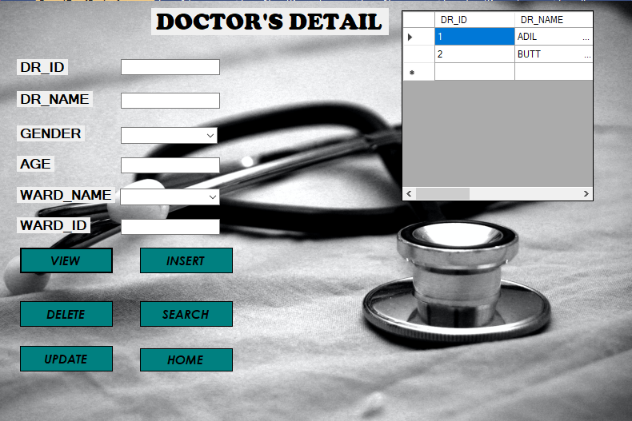

# CLICKING SEARCH

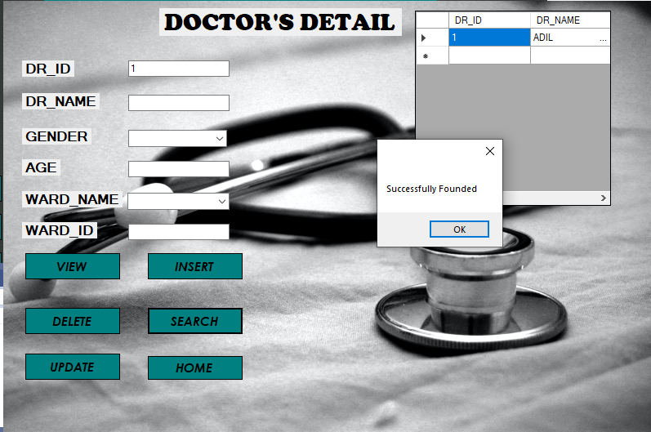

# Deleting

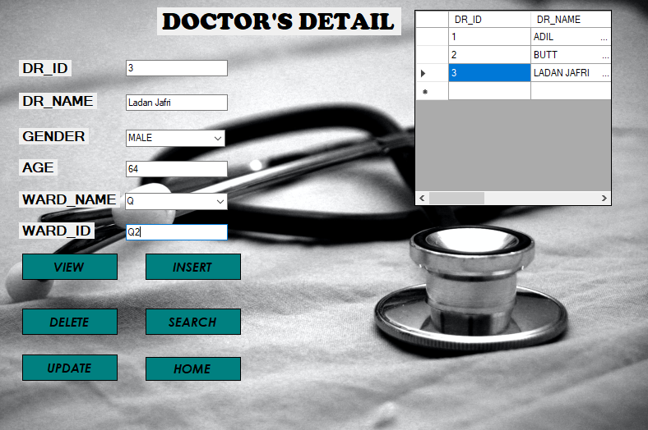

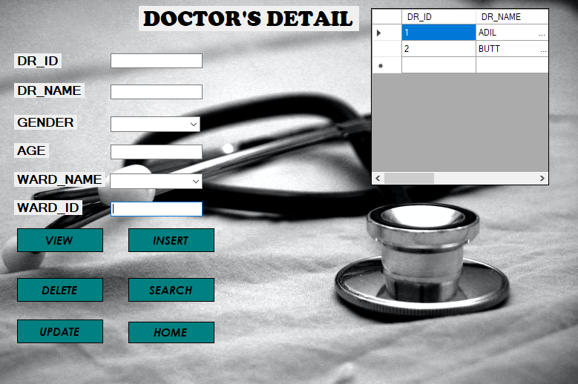

# Inserting id4

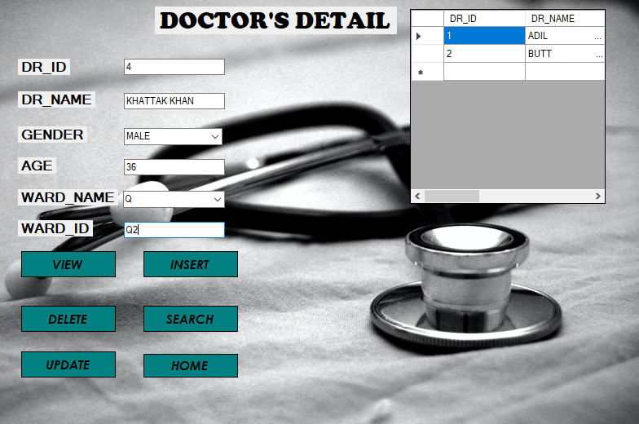

# UPDATING NAME OF ID4

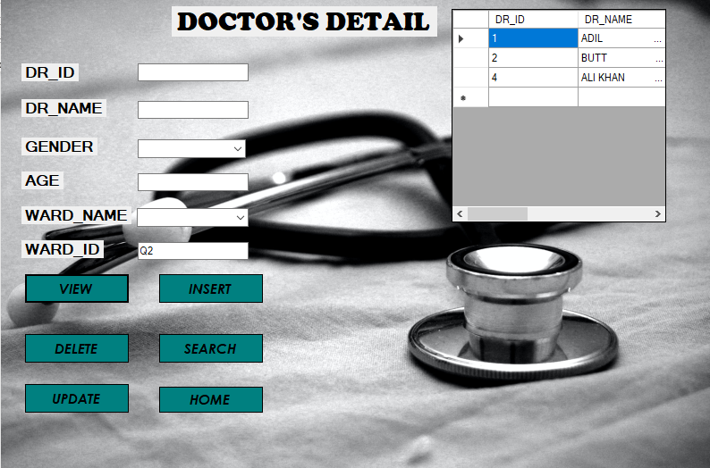

CLICKING PATIENT FROM MENU

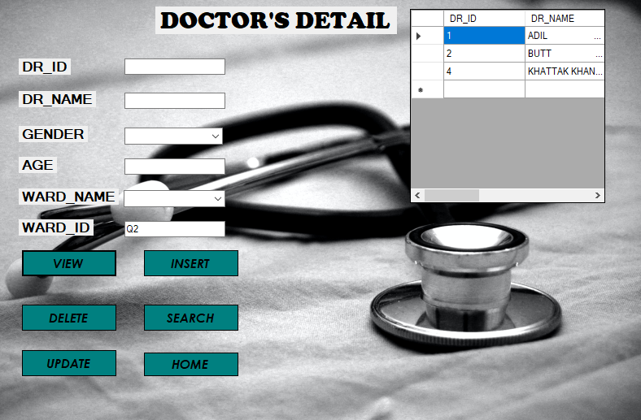

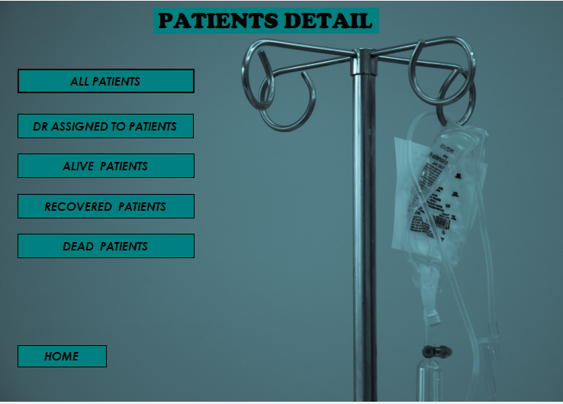

# CLICKING VIEW

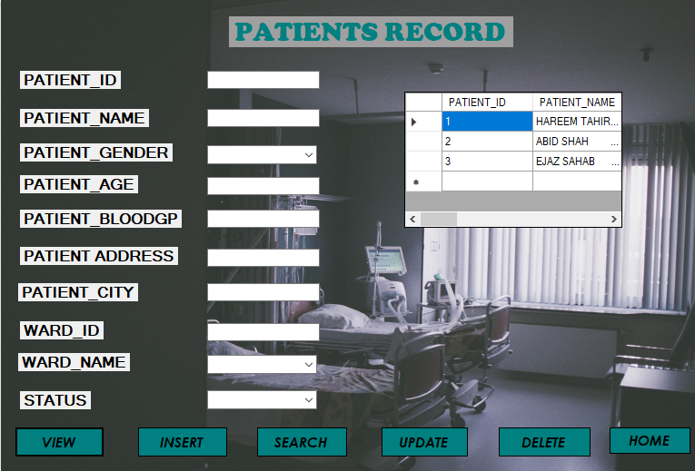

# INSERTING PATIENT

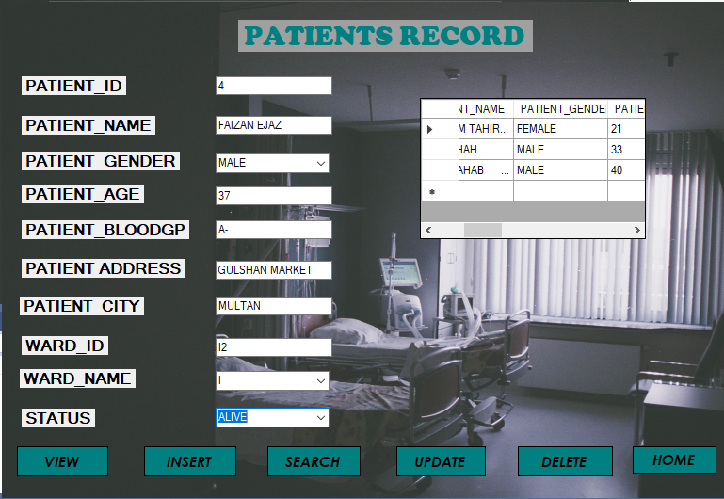

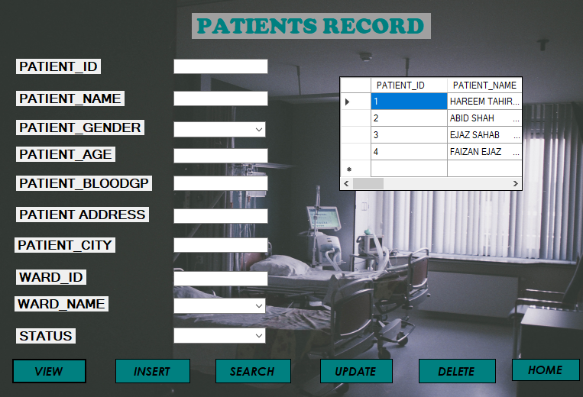

# SEARCHING

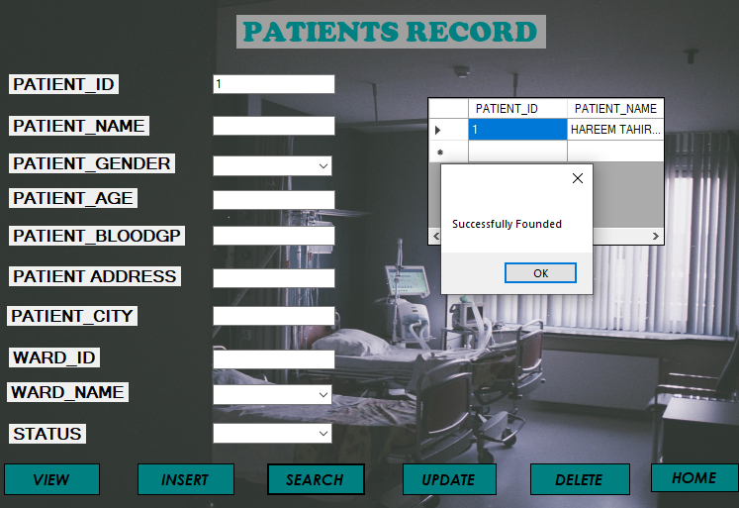

# UPDATING ID 4

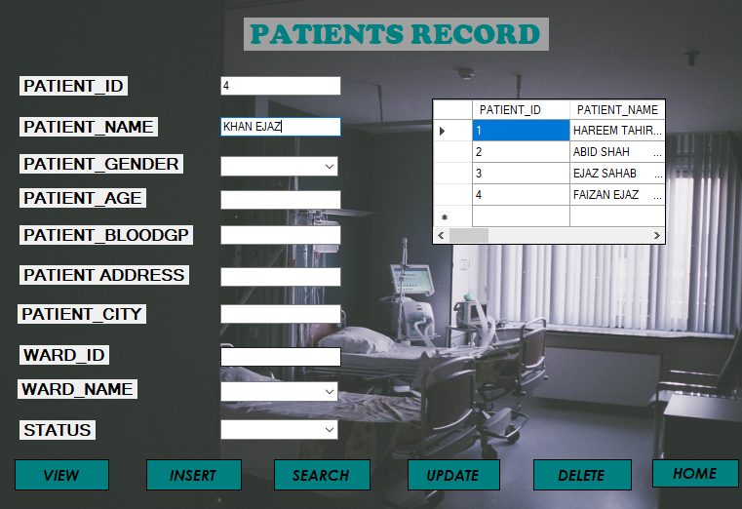

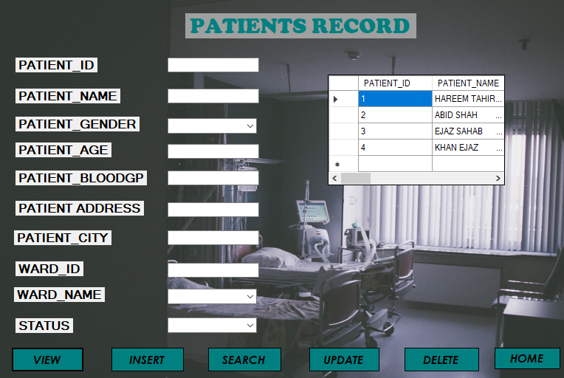

# DELETE ID4

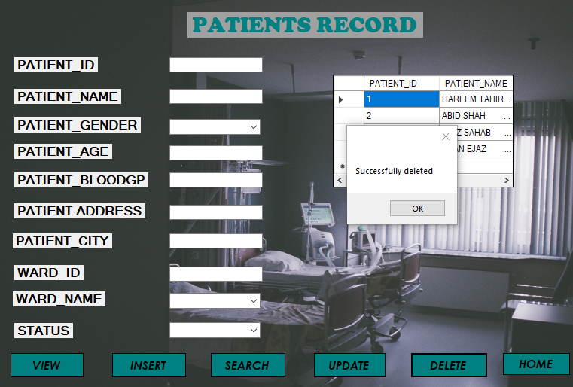

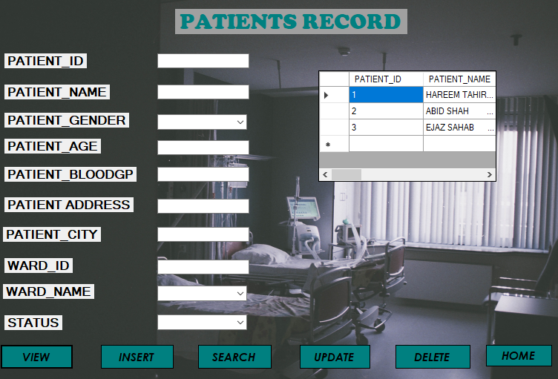

* CLICKING ISOLATION WARD DETAILS FROM MENU

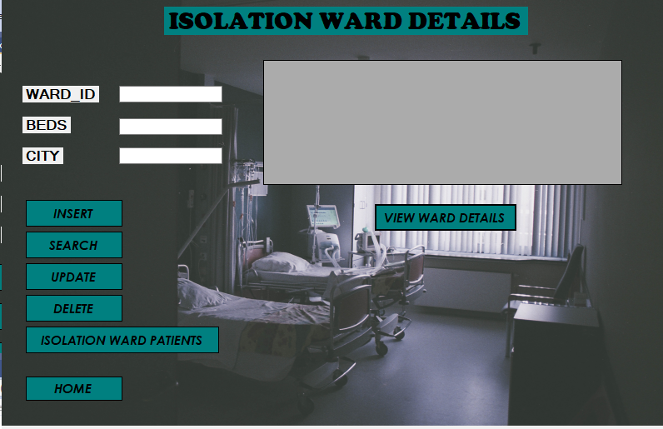

# VIEW WARD DETAILS

# 

# INSERTING

# 

# 

# SEARCHING I2

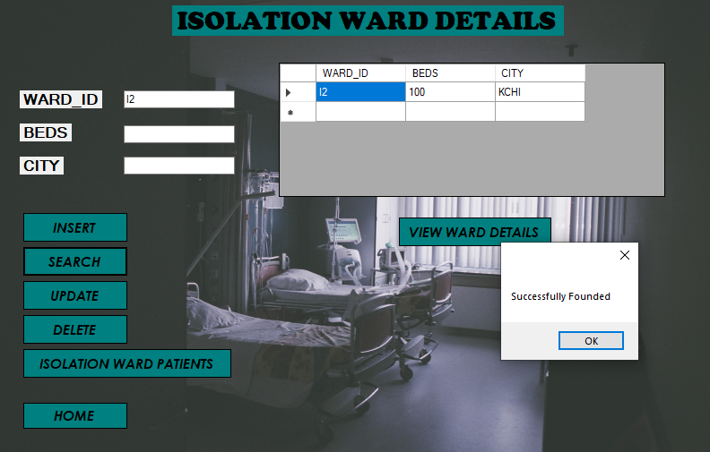

# UPDATE & DELETE FUNCTIONS WILL ALSO BE PERFORMED LIKEWISE.

# CLICKING ISOLATION WARD PATIENTS {FROM ALL PATENTS ONLY THOSE WHO HAVE WARD NAME ‘I’ WHICK IS ONE OF THE COLUMN OF PATIENT RECORD WILL SHOWN HERE}

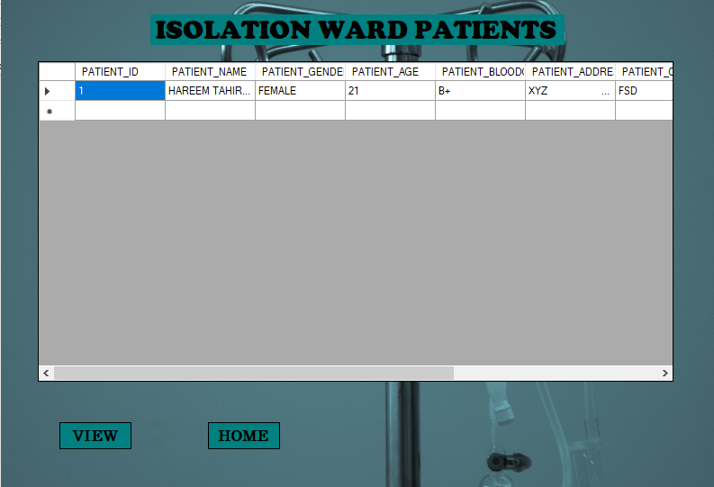

* CLICKING QUARANTINE WARD DETAILS

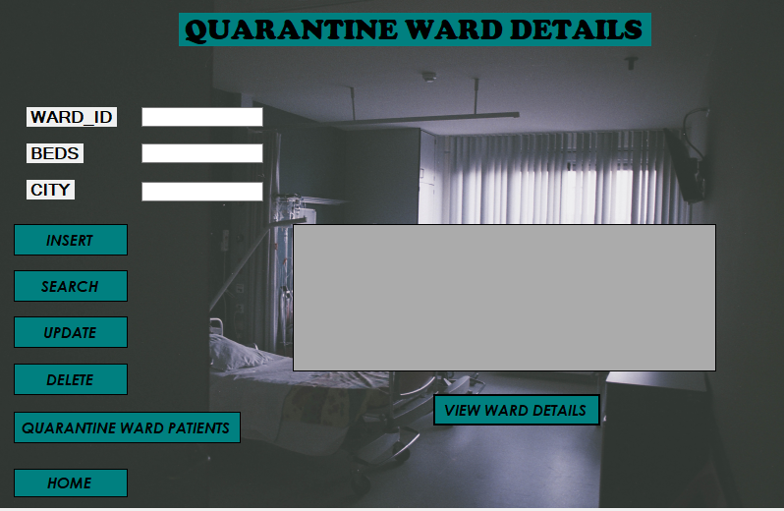

# VIEW WARD DETAILS

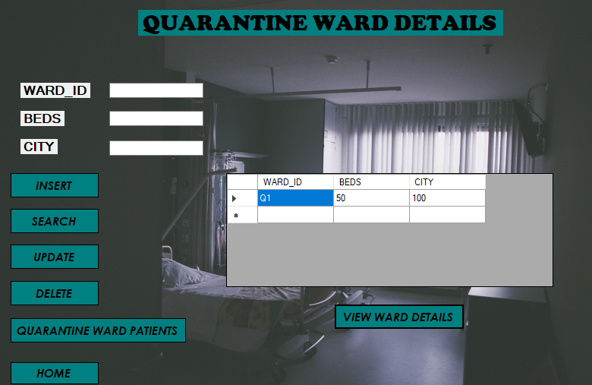

# INSERT

# 

# 

# SEARCHING Q2

# 

# UPDATE & DELETE FUNCTIONS WILL ALSO BE PERFORMED LIKEWISE.

# CLICKING QUARANTINE WARD PATIENTS {FROM ALL PATENTS ONLY THOSE WHO HAVE WARD NAME ‘Q’ WHICK IS ONE OF THE COLUMN OF PATIENT RECORD WILL SHOWN HERE}

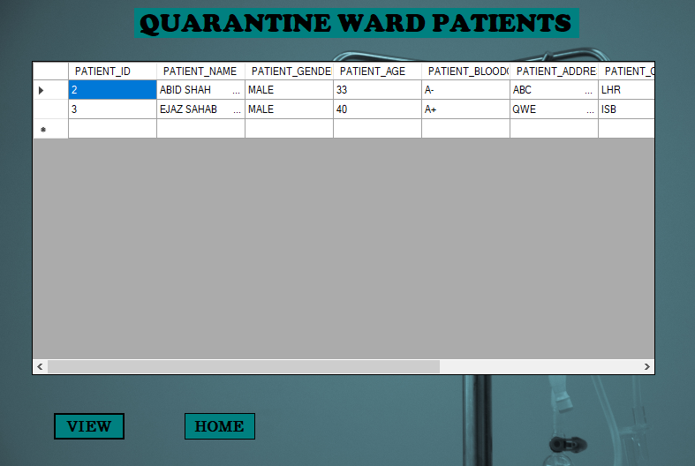

# {TOTAL THERE WERE 3 PATIENTS-2 IN QUARANTINE AND 1 IN ISOLATIONS}

* CLICKING SYMPTOMS|MEASURES|TREATMENT

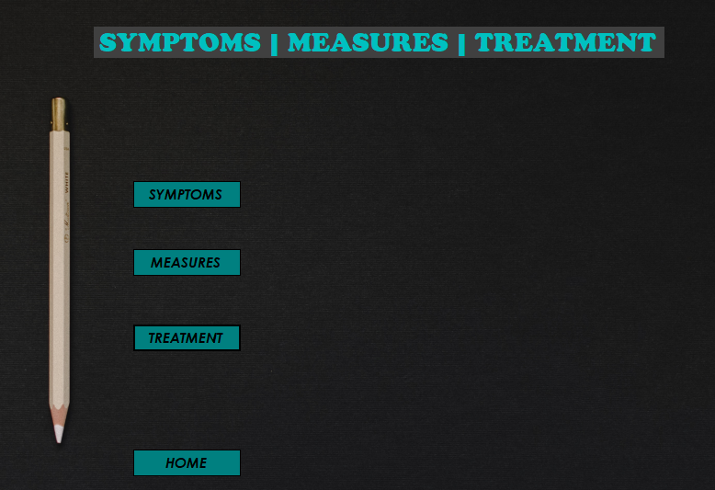

# CLICKING SYMPTOMS

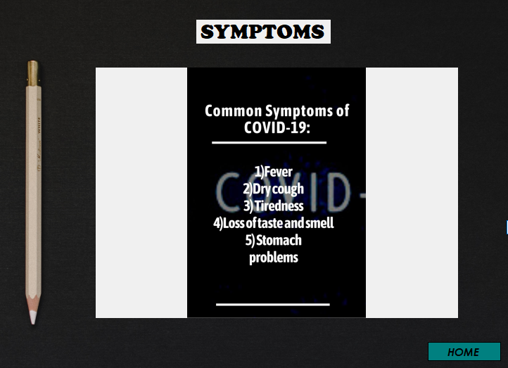

# CLICKING MEASURES

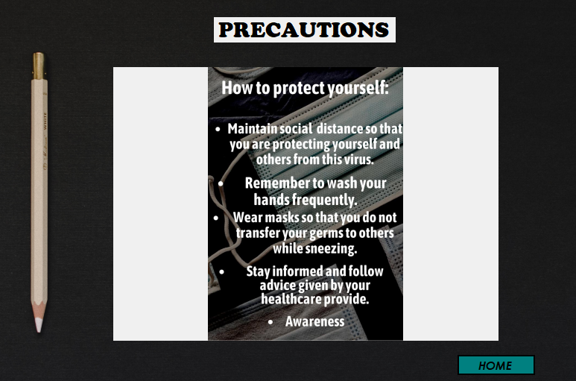

# CLICKING TREATMENT

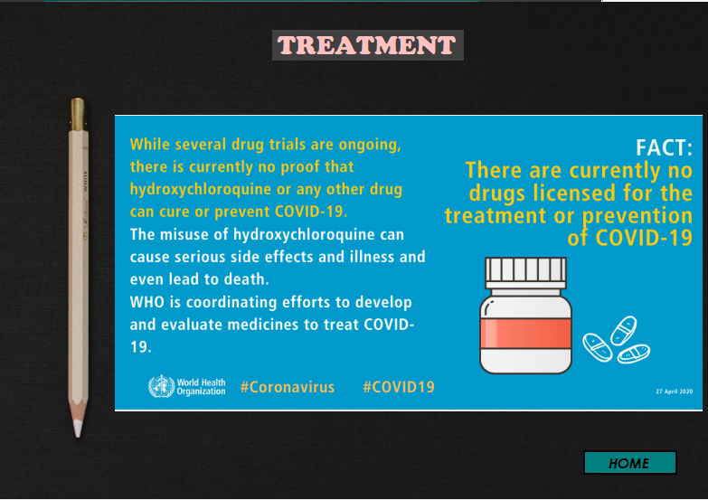

* CLICKING % OF COVID OUTBREAK IN PAKISTAN
* SINCE ONLY 3 PATIENTS IN THIS MANAGEMENT SYSTEM OUT OF 212 MILLION POPULATION OF PAKISTAN, ZERO PERCENT IS BEING SHOWN

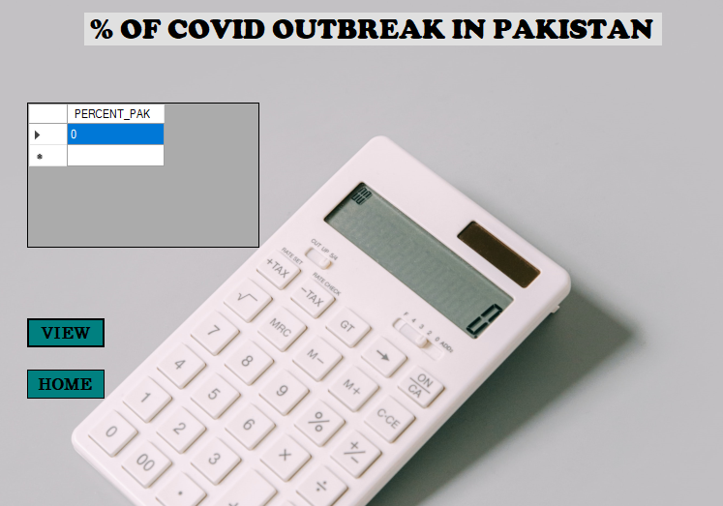

* CLICKING EMERGENCY CALLNO/CENTRE

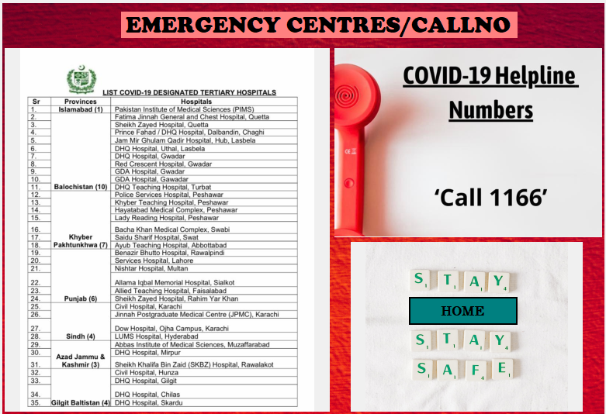

* CLICKING OUR TEAM

